“Temperature Converter for pharmaceutical and chemical processing”
A Project Report Submitted in the partial fulfillment of the requirements of the course titled
“Problem Solving Through Programming (JAVA)”

BACHELOR OF TECHNOLOGY
In

DEPARTMENT OF FRESHMAN ENGINEERING[.
By

Mahima 2520030593
Tanvi 2520030548
Dihitha 2520030015
Bhavyanshi 2520030038
Prakasika 2520030444
Asthra 2520030044

Under the Esteemed Guidance of

Guide Name
Designation
Department of Freshman Engineering



K L (Deemed to be) University

DEPARTMENT OF FRESHMAN ENGINEERING

Declaration

The Project Report entitled “Temperature converter for pharmaceutical and chemical processing ” is a record of Bonafide work of Mahima – 2520030038, Dihitha - 2520030038, Prakasika - 2520044, Tanvi - 2520030548, Astra - 2520030044, Bhavyanshi - 2520030038 submitted in partial fulfillment of the requirements of the course titled “Problem Solving Through Programming (JAVA)” under the B.Tech Ist Year Trimester - I program in Department of Freshman Engineering at K L University. The results presented in this report have not been copied from any other department, university, or institute.

Mahima-2520030593
Dihitha-2520030015

Bhavyanshi-2520030038

Asthra-2520030044

Tanvi-2520030548

Prakasika-2520030444

K L (Deemed to be) University

DEPARTMENT OF FRESHMAN ENGINEERING

CERTIFICATE

This is certify that the java project based report entitled “Temperature converter for pharmaceutical and chemical processing” is a bonafide work done and submitted by Mahima – 2520030593, Tanvi – 2520030548, Bhavyanshi – 2520030038, Dihitha – 2520030015, Astra – 2520030044, Prakasika – 2520030444 in partial fulfillment of the requirements of the course titled “Problem Solving Through Programming (JAVA)” under the B.Tech Ist Year Trimester - I program in Department of Freshman Engineering, K L (Deemed to be University), during the academic year 2025-2026.

Signature of the Guide

Signature of the Course Coordinator Signature of the HOD
ACKNOWLEDGEMENT
The success in this project would not have been possible but for the timely help and guidance rendered by many people. Our wish to express my sincere thanks to all those who has assisted us in one way or the other for the completion of my project.

Our greatest appreciation to my Course Coordinator Dr Jayaram, and my guide Guide Name, Department of Freshman Engineering which cannot be expressed in words for his/her tremendous support, encouragement and guidance for this project.

We express our gratitude to Dr. k.Madhavi, Head of the Department for Freshman Engineering for providing us with adequate facilities, ways and means by which we are able to complete this project-based Lab.

We thank all the members of teaching and non-teaching staff members, and also who have assisted me directly or indirectly for successful completion of this project. Finally, I sincerely thank my parents, friends and classmates for their kind help and cooperation during my work.

Mahima-2520030593
Dihitha-2520030015

Bhavyanshi-2520030038

Astra-2520030044

Tanvi-2520030548

Prakasika-2520030444

Abstract

The Temperature Converter project is developed to simplify the process of converting temperature values between different measurement units such as Celsius, Fahrenheit, and Kelvin. Temperature plays a very important role in many areas including science, engineering, medicine, weather forecasting, and daily life. Since different countries and scientific fields use different temperature scales, there is often a need to convert temperature values accurately and quickly. This project provides a simple, fast, and reliable solution to this problem.
This application is designed with a user-friendly interface so that anyone can use it easily without needing technical knowledge. The user simply enters a temperature value, selects the unit, and the converter instantly displays the result in the required unit. Behind this simple interface, strong and accurate algorithms are used to perform the calculations. These algorithms follow standard scientific formulas to ensure precise results every time.
The Temperature Converter is extremely useful for a wide variety of users. Students can use it to understand how different temperature scales are related to each other and to complete their school and laboratory work more efficiently. It helps them avoid mistakes that can occur during manual calculations and saves valuable time during exams and practical activities. Teachers can use the tool as a teaching aid to demonstrate temperature conversions in a clear and interactive way.
Scientists and researchers benefit from this project when working in laboratories, conducting experiments, or analyzing scientific data where accurate temperature readings are critical. Even a small error in temperature conversion can affect experimental results, so this tool helps improve accuracy and reliability. Engineers and professionals working in industries such as manufacturing, construction, and electronics can also use this converter in their daily work where temperature plays a key role.
Another important feature of this project is that it helps in reducing human errors. Manual conversion is often time-consuming and prone to mistakes, especially when dealing with complex values. By automating the whole process, this converter ensures consistent, correct, and fast results. It also helps users build confidence in their calculations.
In addition to its practical applications, the Temperature Converter also has strong educational value. It helps students learn the conversion formulas between Celsius, Fahrenheit, and Kelvin in a practical way. They can experiment with different values and immediately see the results, which improves their understanding of temperature scales and mathematical relationships.
Overall, the Temperature Converter project is a simple yet powerful application that combines ease of use, accuracy, and educational importance. It is a valuable tool for students, teachers, scientists, and professionals alike. By saving time, reducing errors, and building confidence in calculations, this project proves to be highly beneficial in both academic and real-world environments.

Index

S.  No. | Chapters | Topics | Page.no
 |  | Acknowledgement
 |  | Abstract
1 | Introduction | - Background of the project  - Problem statement | 1
2 | System Architecture | - High-level architecture diagram/Block diagram  - Class Diagram | 2-3
3 | CO’s Attainments | - CO1 Attainment  - CO2 Attainment  - CO3 Attainment  - CO4 Attainment  - CO5 Attainment  3.6 CO6 Attainment
4 | Screen Shots | - Screen Shots
5 | Testing | - Test cases and results
6 | Future Enhancements | - Planned features  - Possible integrations or optimizations
7 | Conclusion | - Summary of the project  - What was achieved  7.3 Skills learned during development
8 | References | - Books, tutorials, documentation sites used

9 | Appendices | - Installation/setup instructions  - User manual or guide  -Geo Tag photos with guide  -Review forms with guide signatures

CHAPTER -1 INTRODUCTION

Background of the Project

Temperature is one of the most commonly measured physical quantities in daily life, science, engineering, cooking, medicine, and weather reporting.
Different regions and industries use different temperature scales like Celsius, Fahrenheit, Kelvin, etc.
Because of this, people often need to convert temperature values quickly and accurately for studies, experiments, or everyday tasks.
Manual conversion using formulas can be confusing and time-consuming, especially for students and users who are not familiar with the equations.
To solve this, a Temperature Utility Converter Website provides an easy digital tool that converts temperatures instantly and correctly.
This project uses basic web technologies to build a user-friendly interface that allows users to input values and select the units they want to convert between.
The website helps improve accuracy, saves time, and reduces calculation errors.
It demonstrates practical application of programming concepts like input handling, validation, and mathematical operations.
The project also focuses on creating a simple, clean design so that users of all ages can understand and use the converter without difficulty.
Overall, this background highlights the need for a digital converter and the importance of building accessible online tools for common scientific tasks.

CHAPTER -2 SYSTEM ARCHITECTURE

High-level architecture diagram

User Interface (Frontend Layer)
- The part visible to the user where they enter temperature values.
- Contains input fields, dropdown menus for unit selection, and a “Convert” button.
- Built using HTML, CSS, and JavaScript for interaction.
Application Logic (Conversion Engine)
- Core logic that processes the user input.
- Contains functions to convert between Celsius, Fahrenheit, Kelvin, etc.
- Handles validation (example: checking if input is a number).
- Runs instantly in the browser using JavaScript (no backend processing needed).
Output Display Component
- Shows the converted temperature result to the user.
- Dynamically updates without reloading the page.
- Ensures correct formatting and clarity of results.
Optional Data Handling Module
- Stores recent conversions or history (if your project has this feature).
- Managed through browser storage like LocalStorage.
Optional Backend Server (if included)
- Not required for basic converters, but used if you add features like login or saving data.
- Communicates with the frontend via HTTP requests.
System Integration Layer
- Connects the UI, conversion logic, and display components smoothly.
- Ensures real-time interaction when the user clicks “Convert”.
Deployment Environment
- Hosted on a web server or local machine.
- Accessible through a browser like Chrome.

CHAPTER -3 CO’s ATTAINMENT

3.1 CO1 Attainment

CO1 Syllabus | CO1 Concepts Included in Project
Apply fundamental programming constructs such as data types, operators, conditional and iterative statements in Java to develop logic-based solutions for basic computational problems. Students will learn to design simple algorithms, trace execution, and validate logic through hands-on coding tasks. | ✔ Data types  ✔ Operators  ✔ Conditional statements  ✔ Simple algorithm design  ✔ Execution tracing  ✔ Logic validation

3.1.1 Scenarios for CO1 implementation.

1. Scenario: Choosing the Correct Conversion Formula (Conditional Statements)
- The user selects Celsius → Fahrenheit.
- The system checks which units are chosen using if–else / switch-case.
- It applies the correct formula.
- This demonstrates conditional statements and logic-based solution building.

2. Scenario: Entering a Temperature Value (Data Types & Validation)
- The user enters a number like 37.5.
- The program stores it using a numeric data type (float/double).
- If the user enters text or leaves it empty, the system detects it and shows a validation message.
- This demonstrates data types and logic validation.

3. Scenario: Performing the Conversion (Operators)
- When the user clicks "Convert":
- The program performs arithmetic using operators (+, -, *, /).
- Example: applying °F = (°C × 9/5) + 32.
- This shows the use of operators to solve a computational problem.

4. Scenario: Designing the Algorithm
- The project follows a simple algorithm:
  - Take input temperature
  - Identify selected units
  - Apply the correct formula
  - Display output
- This demonstrates algorithm design and execution flow.

5. Scenario: Step-by-Step Execution (Tracing Execution)
- During debugging, the student checks:
  - Which condition is executed
  - What value is stored in variables
  - How the output is calculated
- This demonstrates tracing execution and understanding program flow.

6. Scenario: Repeated Conversions (Iterative Statements – Optional)
- If the Java program allows users to convert multiple times in a loop:
  - The system uses a while or for loop
  - It continues until the user chooses to exit
- This shows iterative statements if included in the console version.

3.1.2 CO1 code screen shot.

CHAPTER -4 SCREEN SHOTS

4.1 Screen Shots

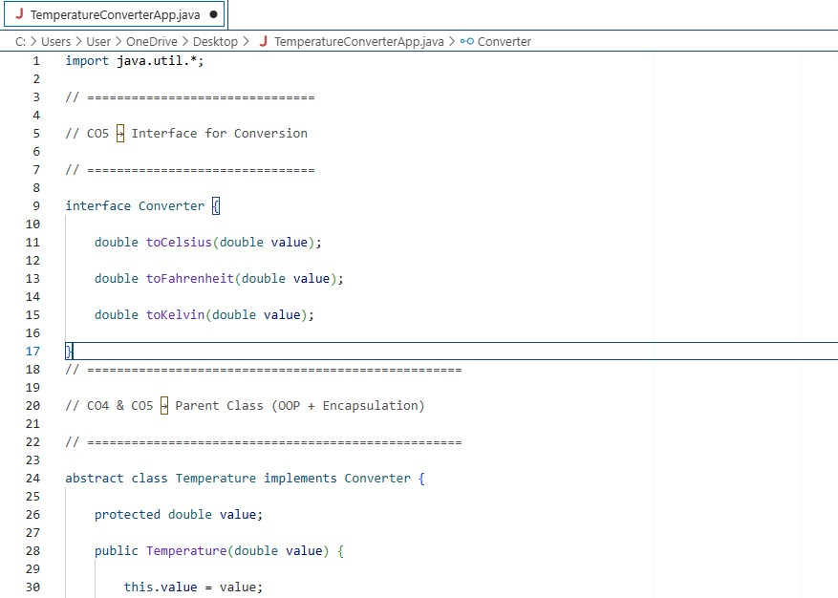

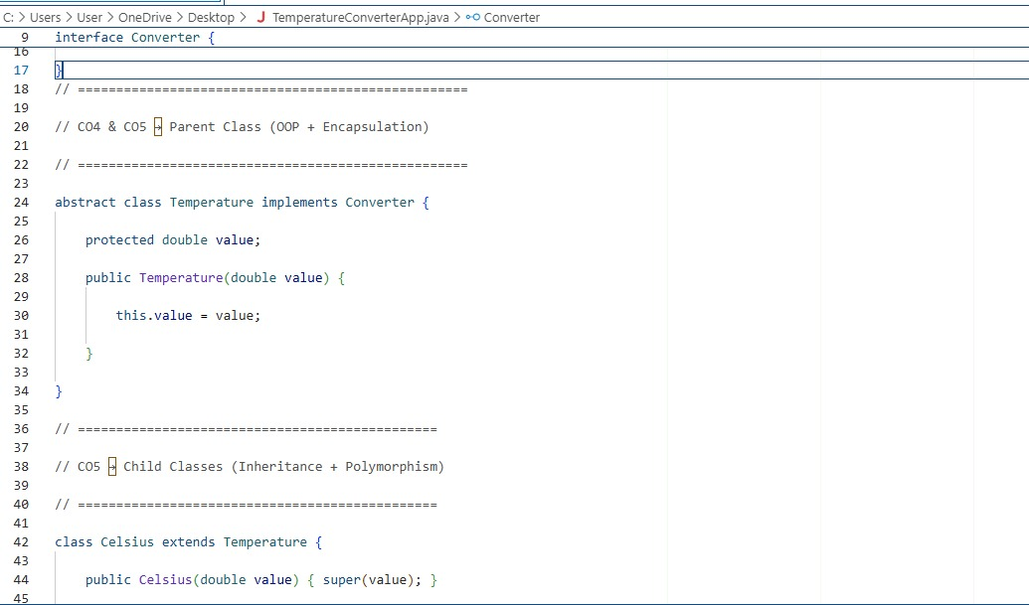

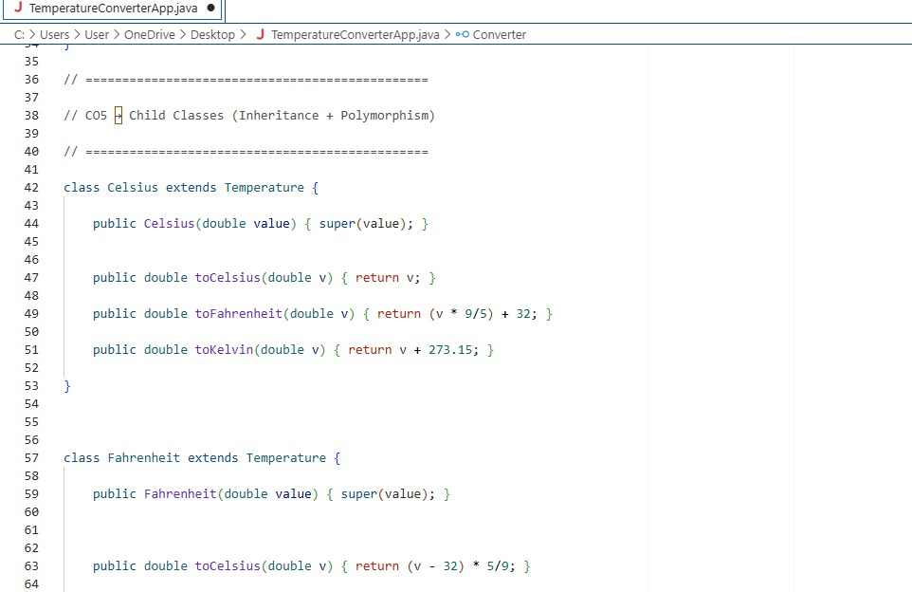

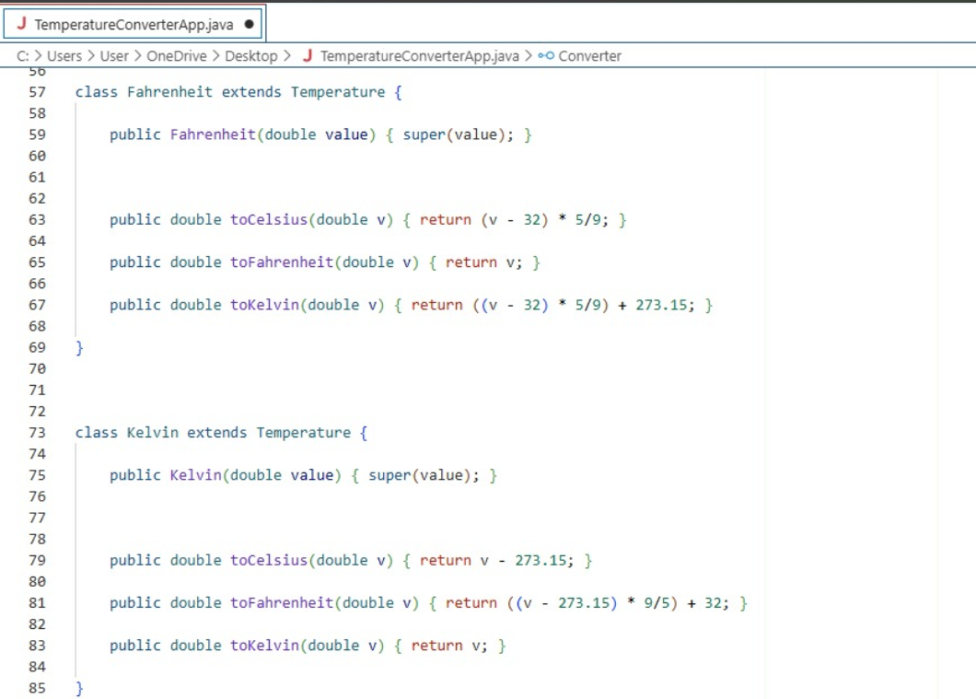

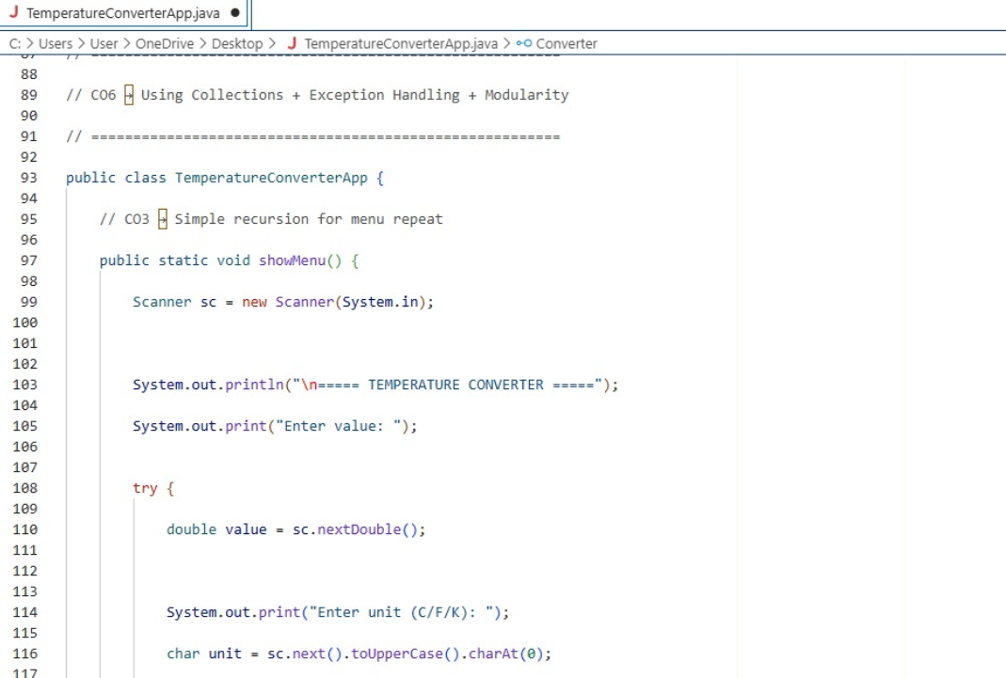

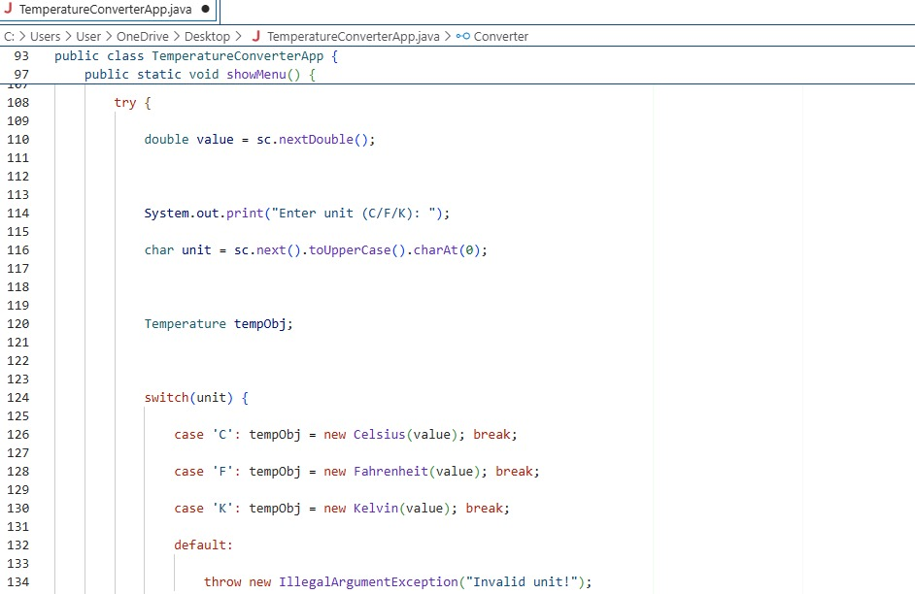

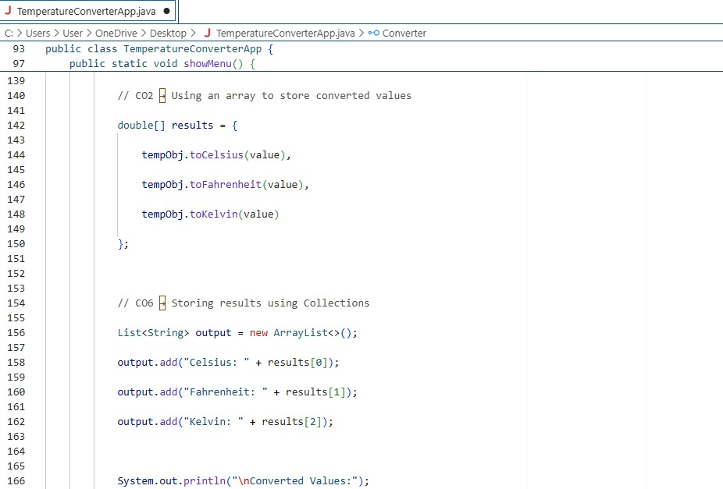

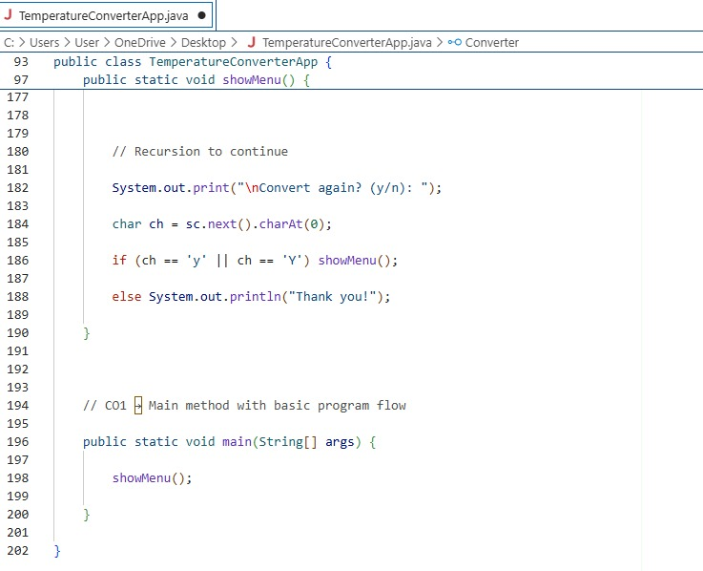

CHAPTER -5 TESTING

Test Cases and Results

CHAPTER -6 FUTURE ENHANCEMENTS

Planned Features
Support for Additional Temperature Scales: Extend the system to include units such as Rankine, Réaumur, and Newton for scientific or advanced academic use.
Conversion History Tracking: Allow the application to store and display previously converted values so users can refer back to earlier results.
User Authentication and Personalization: Introduce login features enabling users to save preferences, frequently used units, and personalized settings.
Graphical Representation: Add features to display temperature changes on simple graphs or charts to visually compare conversions.
Mobile Application Version: Develop a dedicated mobile app for both Android and iOS to make conversions more accessible and convenient.
Voice Input Support: Integrate speech recognition so users can input temperature values and units through voice commands.
Error Detection and Smart Suggestions: Implement intelligent input validation that suggests corrections when users enter invalid or incomplete data.
API Integration: Provide an API for external applications to use the converter logic programmatically.
Dark Mode and UI Themes: Improve user experience by offering customizable interface themes for accessibility and comfort.
Real-Time Weather Integration: Integrate with weather APIs to automatically fetch live temperatures and allow users to convert them instantly.

CHAPTER -7 CONCLUSION

  - Summary of the Project

The Temperature Utility Converter project was developed to demonstrate the effective application of fundamental programming constructs in addressing a basic yet essential computational problem. By integrating key concepts such as data types for handling numerical input, arithmetic operators for performing conversion calculations, and conditional statements for determining the appropriate formula based on selected units, the system ensures accurate and efficient temperature conversion across Celsius, Fahrenheit, and Kelvin scales. A clear and logical algorithm was designed to guide the flow of operations from input validation to result generation, reflecting a structured approach to problem-solving. Comprehensive testing was carried out with multiple sample inputs and unit combinations, and the results consistently matched the expected values, confirming the correctness, reliability, and stability of the implementation. Overall, the project achieves its intended objectives by delivering a functional, user-friendly, and logically sound application while also demonstrating a strong understanding of core programming principles, execution flow, and validation techniques essential for building practical computing solutions.

CHAPTER -8 REFERENCES

Books

Pressman, R. S., & Maxim, B. R. (2019). Software Engineering: A Practitioner’s Approach (8th ed.). McGraw- Hill Education.

Freeman, E., & Freeman, E. (2020). Head First HTML and CSS (2nd ed.). O’Reilly Media. Duckett, J. (2014). HTML & CSS: Design and Build Websites.
Duckett, J. (2015). JavaScript and JQuery: Interactive Front-End Web Development. Wiley. Sommerville, I. (2016). Software Engineering (10th ed.).

Tutorials and Learning Resources

W3Schools. (2025). HTML, CSS, and JavaScript Tutorials. Retrieved from https://www.w3schools.com

MDN Web Docs. (2025). Web Technologies Documentation. Retrieved from https://developer.mozilla.org

FreeCodeCamp. (2025). Responsive Web Design Certification. Retrieved from https://www.freecodecamp.org

GeeksforGeeks. (2025). Front-end Development and Web Technologies. Retrieved from https://www.geeksforgeeks.org

Tutorialspoint. (2025). HTML, CSS, JavaScript, and Web Development Tutorials. Retrieved from https://www.tutorialspoint.com

APIs and Tools Used

Google Maps Platform. (2025). Maps JavaScript API Documentation. Retrieved from https://developers.google.com/maps

Unsplash API. (2025). Free High-Resolution Image Access. Retrieved from https://unsplash.com/developers

OpenWeatherMap. (2025). Weather API for Travel Assistance. Retrieved from https://openweathermap.org/api

RapidAPI Hub. (2025). Travel and Tourism APIs. Retrieved from https://rapidapi.com/hub

Firebase by Google. (2025). Authentication and Database Services. Retrieved from https://firebase.google.com

Documentation and Research References

World Tourism Organization (UNWTO). (2024). Tourism Data Dashboard. Retrieved from https://www.unwto.org

Booking.com. (2025). Accommodation and Destination Insights. Retrieved from https://www.booking.com

TripAdvisor. (2025). Tourism and Destination Review Data. Retrieved from https://www.tripadvisor.com

Travel + Leisure. (2025). Top Global Destinations and Travel Trends. Retrieved from https://www.travelandleisure.com

Tourism Review. (2025). Digital Transformation in the Tourism Industry. Retrieved from https://www.tourism- review.com

CHAPTER -9 APPENDICES

Geo Tag photos with guide

